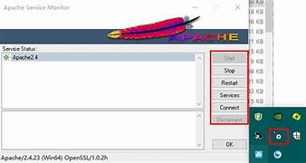

Set up Apache web server in windows Ec2 Instance

* Create your account on amazon awa using root on IAM user.
* Select region (Asia pacific Mumbai).
* Open Ec2 services and click on instance
* Name your instance and select windows O.S.
* Now create your key pair name (key pair type should be RSA and format . pem ).
* After creating your key it will be downloaded Automatically.
* Allow SSH traffic from my IP address only.
* Now click on launch instance.

# After launching your instance go to your instance and select your instance and click on connect then click on RDP client and download remote desktop file.

* Now click on get password and click on upload private key.
* Choose your Pem file and upload it.
* Then click on decrypt password and Copy Your password.
* Open your remote desktop file and paste your password and click on connect.
* Now your virtual window will be opened.
  + - NOW FOE INSTALLING APACHE SERVER ON YOUR VM :----
* Firstly open the browser and search “ Apache server download for windows.
* Go to Apache website and download and Zip file for windows.
* Unzip the file and extract the folder Apache24 to C Drive.
* Then Open Command prompt and run as administrator.
* Run command “cd c:\ install”.
* //Now Apache server is installed successfully.
* Go to services, click on Apache 2.4 then start the service.
* pen Browser search localhost ‘12 localhost ‘127.0.0.1 .
* //It shows “It WORKS
* . pen Browser search localhost ‘127.0.0.1 .
* //It shows “It WORKS” ! .